Graham Westwell Therapy
MSc., Dip. Counselling., PGCE.
07985 457 198
hello@grahamwestwell.com

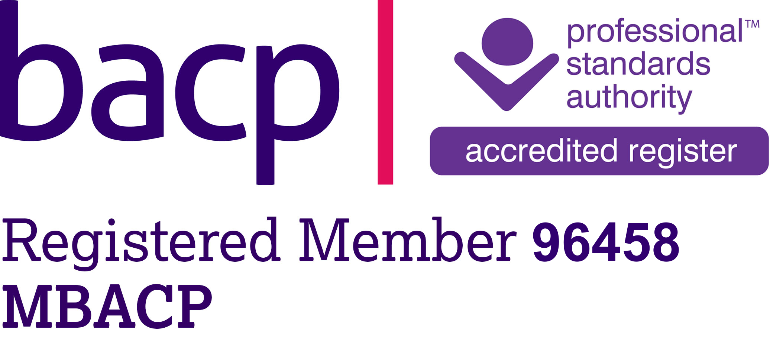

Person-Centred Experiential (PCE) Personal Development (PD) Group,
(November 2025 – February 2026). Online Group.

What is a PCE PD group?

A person-centred experiential personal development group is an opportunity to encounter each other in a way that deliberately upholds the attitudinal gestalt of genuinely empathic prizing (Rogers, 1957; 1959). A PCE PD group can be a rare experience of feeling highly present with a group of like-minded people. The group is intended for people interested in learning more about their own experiential way of being.

The ‘tone’ of the group

The group will be co-created by all group members. What will the ‘spirit’ of the group? What commitments will we need to make to each other so that this an optimal space for emotional process and experiential flourishing? These are qualities to be explored in our first meeting and throughout the life of our group.

I would like to suggest that ‘openness’ within a PCE PD group can be characterised by a willingness to receive each other empathically and to actively and continuously work on pre-conceived ideas of how things ‘should’ be. How might you pay attention to your whole body to help you empathically attend towards another person’s process? How might you articulate this bodily felt understanding with greater clarity? I find that these are the kinds of learning processes which can be explored in a PCE PD group.

I would like to facilitate and encourage a curious and gentle reflexivity within the group. I am interested in the quality of tenderness as an essential aspect of a PCE PD group. In the following short excerpt, I am writing about tenderness as a relational quality in PCE practice. I feel the same quality applies to a PCE PD group:

“Tenderness is really important in experiential work, and is particularly so within this aspect of encounter. Tenderness, perhaps, is a rare quality in today’s fast-paced, consumer-oriented and media-constructed society. Little attention seems to be paid to the small moments in-between. Careful and soft attention is necessary to notice these small moments within the client’s process. When we do pay such tender and careful attention, then it becomes more likely that we are sufficiently meeting the client in their process and more likely to fully receive them. Experiential therapists in training are encouraged to cultivate their ability to carefully and tenderly notice these moments and to attend to them with care and compassion.” (Westwell, 2016, p. 68)

What images, thoughts and feelings does the word ‘tenderness’ evoke for you? What do you notice about your need for tenderness within your own life?

Therapeutic but not therapy

It is important to remember that, whilst there is every expectation that the PD group will be of therapeutic value for each group member, it is not intended as group or individual therapy. It may be helpful, if emotive material comes up for you during the process of the group, for you to organise your own individual therapy. That said, the group is intended to be an emotionally secure space, which will enable you to explore your own emotional process in a way that is growth-full for you.

Group boundaries

These will be discussed by the group during our first meeting and will be living throughout all of our time together. The boundaries are co-created by the group and form a ‘living contract’, which reflect ‘ways of being-with’ rather than a checklist of ‘things to do’.

Size of the group

The group will be a maximum of nine participants and one facilitator – making a maximum group total of nine people. The group will be facilitated by Graham Westwell.

How we will meet

The group will meet online for 2 hours each fortnight for four months. The group meetings will take place by Zoom (6.30 – 8.30, GMT) on the following dates:

2025

Tuesday 4 November
Tuesday 18 November
Tuesday 2 December
Tuesday 16 December

2026

Tuesday 6 January
Tuesday 20 January
Tuesday 3 February
Tuesday 17 February

I will send a Zoom link to your email address in advance of each meeting. Please make sure that you have a confidential space available, where you will be uninterrupted, and where you will feel comfortable to be present with your emotions and process.

Preparing for the group

It may be helpful for you to reflect on the following: What are you hoping to experience? Is there anything you are hoping to learn? What do you need from the group? What are you willing to share with the group?

Payment

The fee for attending will £320 for all eight sessions. There are two payment options by BACS transfer:​
- Pay the full fee upfront - at a discounted rate of £280 (instead of £320).
- Pay in two instalments of £160. The first instalment is to secure your place and the second is payable before the 4th meeting.

You can pay by using BACS transfer using the following details:

Business name: Mr Graham Westwell
Trading name: Graham Westwell Therapy
Sort code: 40-18-00
Account number: 10545376

Please complete payment to secure your place. Please note that your payment is non-returnable.

References

Rogers, C.R. (1957). ‘The necessary and sufficient conditions for therapeutic personality change.’ Journal of Consulting Psychology, 21, 95-103.

Rogers, C.R. (1959). ‘A theory of therapy, personality, and interpersonal relationships as developed in the client-centered framework.’ In S. Koch (Ed.), Psychology: The Study of a Science, (Vol 3, pp. 184-256). McGraw-Hill.

Westwell, G. (2015). Experiential therapy. In P. Wilkins (Ed.), Person-centred and experiential therapies: Contemporary approaches and issues in practice (pp. 64-76). Sage.

